**EGR 7040 *Design Optimization***

**Wright State University, Autumn 2015**

**Homework # 5 – Due electronically**

Recall the 5-step process for formulating the optimization problem. Now to solve an optimization problem we can use a corresponding step-by-step approach:

Step 1: Set up the Coordinate System

Step 2: Plot the boundaries of inequality constraints

Step 3: Identify the Feasible Region for each inequality

Step 4: Identify the overall Feasible Region

Step 5: Plot contours of the Objective Function

Step 6: Identify the Optimum Solution

Solve the following problems according to the *graphical solution process*, in your own words and to the best of your ability. Following the step-by-step process, do the following problems (3.17, 3.21, 3.27, 3.31, 3.37, 3.38, 3.45):

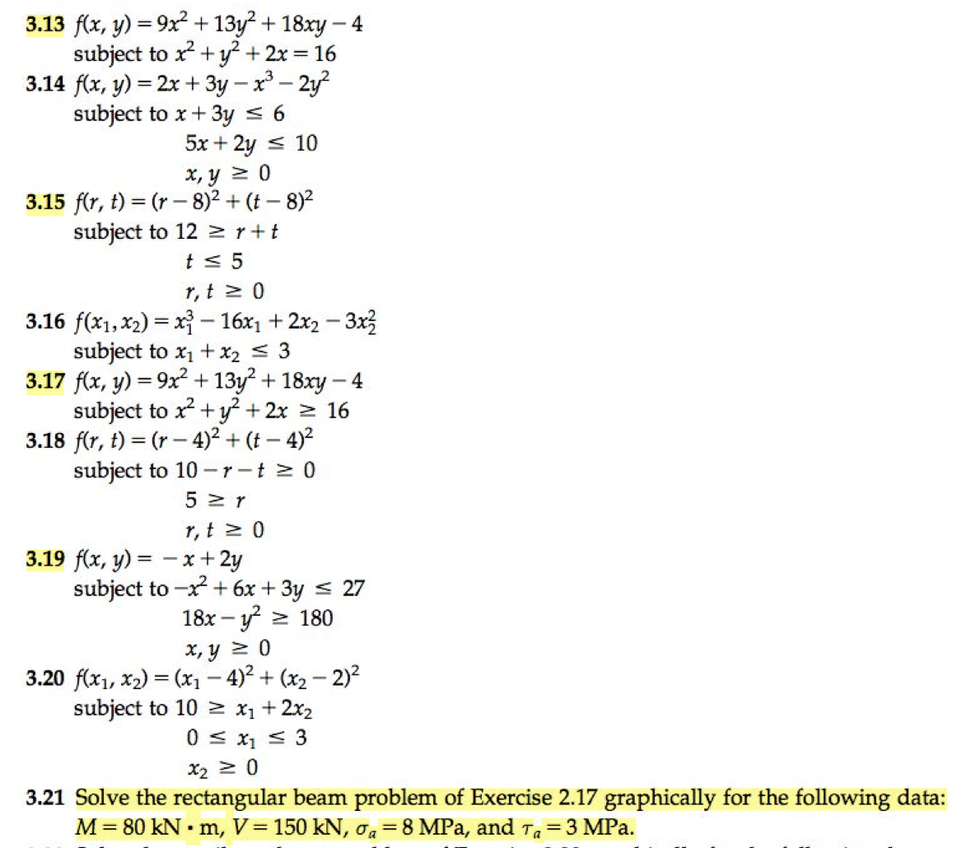

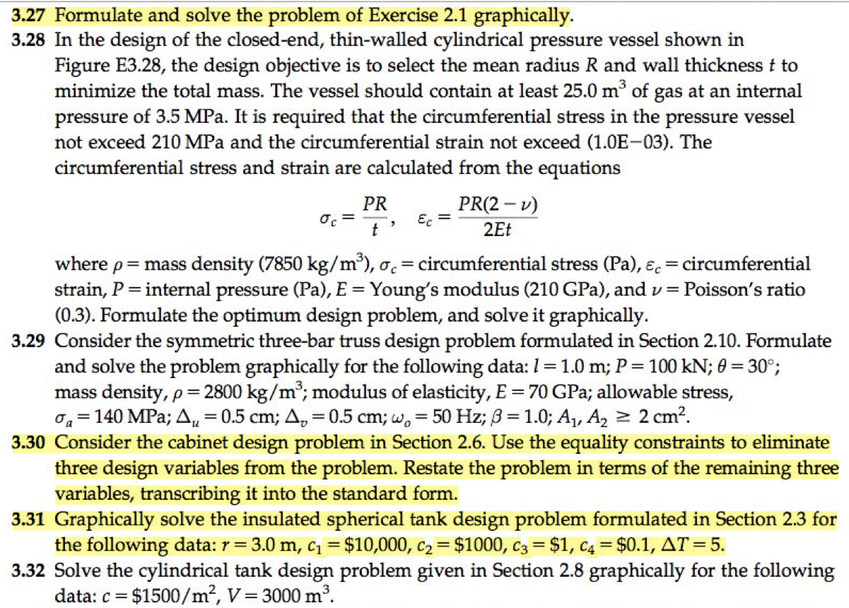

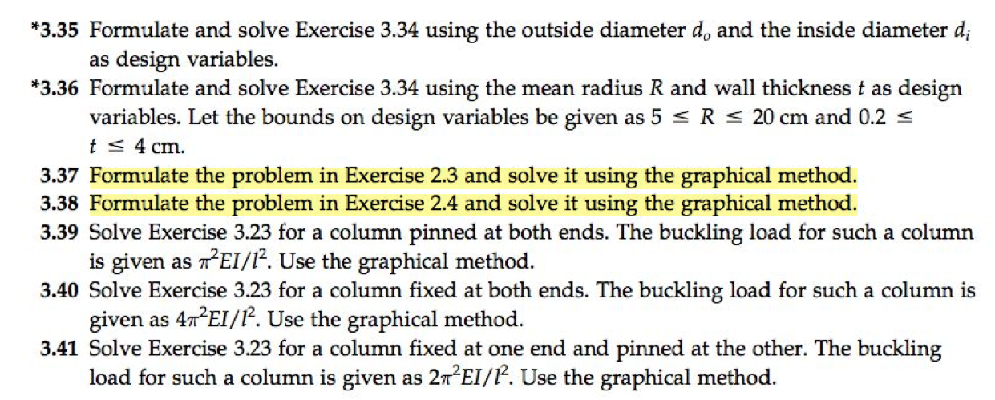

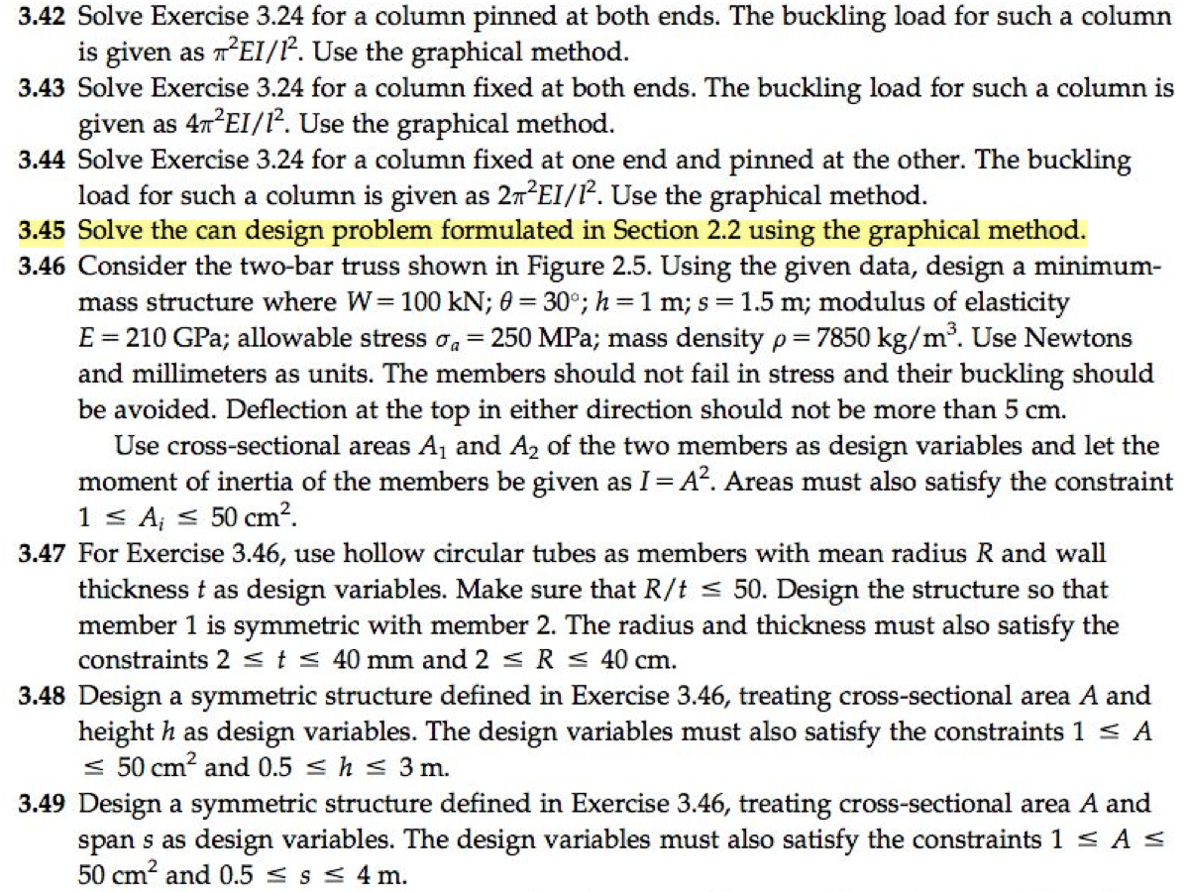

**Format:**

* Typed (nothing handwritten), short paragraph for each question. Must include original problem statement, step-by-step description and graphical solution
* Concise, clear, and complete; in your own words (don’t copy from the text)
* Find other source material to develop your understanding of the concepts and ideas (online or other books); include as “References”
* Submit electronically via WSU’s “WINGS” on-line class web-site (MS Word or PDF or other readable file format)
* Due date: Sunday 11 October 2015 by 11:55PM

*It is OK to check your answers using MATLAB or Octave, however do not turn in printouts from MATLAB except figures/graphs. Show intermediate steps and be concise, clear, and complete.*

Upon completion of Chapter and this homework sequence, you will be able to

* Graphically solve any optimization problem having two design variables
* Plot constraints and identify their feasible/ infeasible side
* Identify the feasible region (feasible set) for a problem
* Plot objective function contours through the feasible region
* Graphically locate the optimum solution for a problem and identify active and inactive constraints
* Identify problems that may have multiple, unbounded, or infeasible solutions
* Explain basic concepts and terms associated with optimum design

Reference:

Arora, Jasbir. *Introduction to Optimum Design, 3rd Edition*. Academic Press, 08/2011